**Week 2 Lab Activity: Recognizing Variables and Relationships in Social Research**

**Name: ___MOST NAZNIN BEGUM______Date:9/01/2021__________________________**

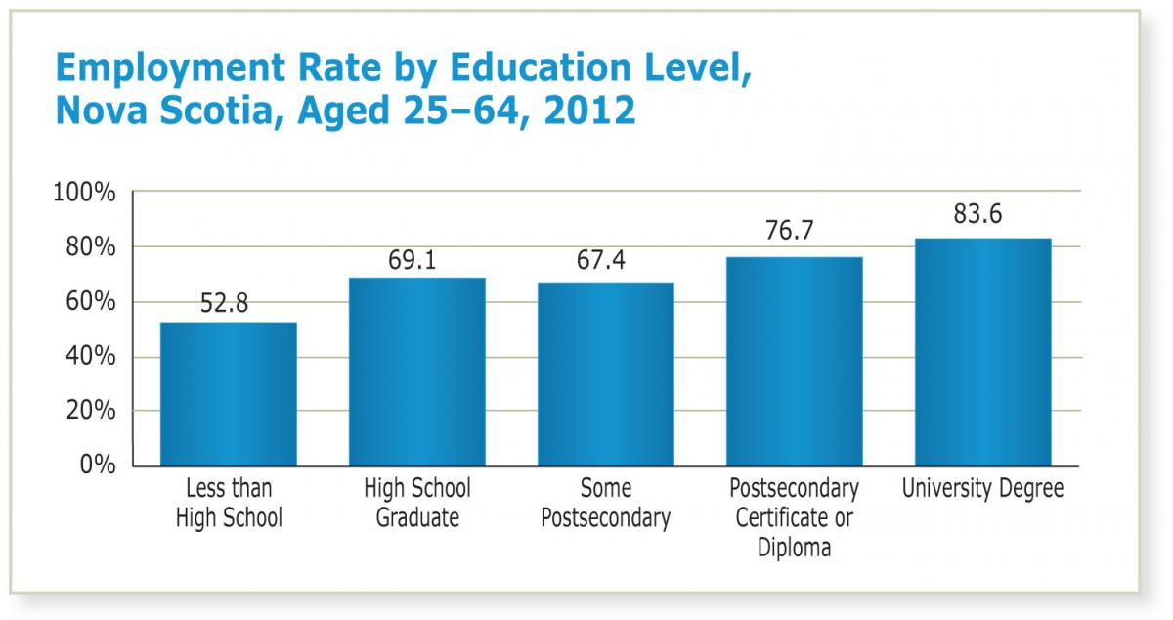

**Questions:**

(1) What variables are included in this graph (Note: there are only TWO variables shown)?

* Employment rate
* Education level

(2) Provide at least TWO attributes for each of the variables.

* Attributes of education level include less than high school, a high school graduate, some postsecondary, certificate or diploma in postsecondary, and a university degree.
* Attributes for employment rate 52.8%, 83.6%, 67.4%, 76.7%and 69.1%.

(3) Is there a relationship? Y / N

(4) If so, describe it.

* As the education level goes up, the employment level also increases, therefore it is a positive relationship.

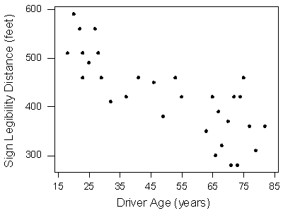

<http://bolt.mph.ufl.edu/6050-6052/unit-1/case-q-q/scatterplots/>

**Questions:**

(1) What variables are included in this graph (Note: there are only TWO variables shown)?

* Driver age and
* Sign legibility distance in feet.

(2) Provide at least TWO attributes for each of the variables.

* Attributes of age include 25 years, 45 years, and 65 years.
* Attributes for sign legibility distance (Feet) include 300 feet, 400 feet, and 500 feet.

(3) Is there a relationship? Y / N

(4) If so, describe it

* As the age of the driver increases, the sign legibility distance decreases, therefore it is a negative relationship.

**Marriage Rates Among Young Adults Ages 25-34, 1965-2010 (Percent)**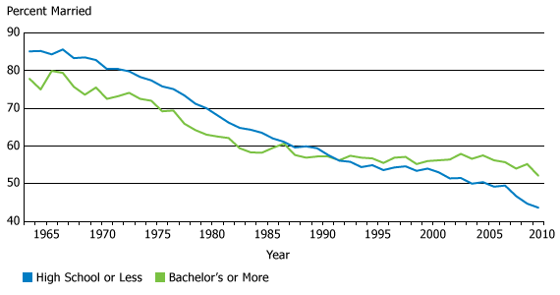

<http://www.prb.org/Articles/2010/usmarriagedecline.aspx>

**Questions:**

(1) What variables are included in this graph (Note: there are only THREE variables shown)?

* High school or less
* Bachelor or more
* Year

(2) Provide at least TWO attributes for each of the variables.

* Attribute for high school or less include high school and less than high school.
* Attribute for bachelor include having a bachelor’s degree or more.
* Attributes of year include 1970, 1980, 1990, 2005, and 2010.

(3) Choose two of the variables you listed for which you think there’s a relationship:

Variable 1: **Bachelor or more** Variable 2: **Year**

(4) Describe the relationship:

* The marriage rates for young adults having a degree or more decreases as the year progressed, therefore there is a negative relationship.

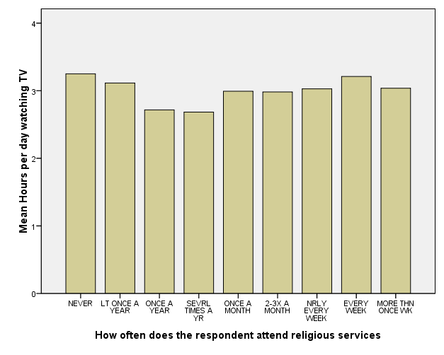

**Questions:**

(1) What variables are included in this graph (Note: there are only TWO variables shown)?

Mean hours per day watching TV

How often does the respondent attend religious service?

(2) Provide at least TWO attributes for each of the variables

Mean hours per day watching TV: 1, 2.

How often does the respondent attend religious service: Never, at least once a year?

(3) Is there a relationship? No

There is no particular relationship between the number of times a respondent attends a religious service and the hours spend watching Tv.